**CSE523 Machine Learning**

**Prof. Mehul Raval**

**Anomaly detection in computer networks to identify unusual activity or potential security threats**

**Week 6 Report**

| **Name** | **Enrolment Number** |
| --- | --- |
| Vatsal Patel | AU2040043 |
| Shreya Karia | AU2040076 |
| Digant Patel | AU2040086 |
| Samarth Chauhan | AU2040097 |

We implemented the Gaussian Naive Bayes algorithm this week. We executed it in 2 different ways i.e. using PCA and without PCA. The accuracy was the same in both cases.

We made an assumption that the values associated with each class are distributed according to Gaussian or Normal distribution.

We got an accuracy of 85.02% which is poor compared to accuracy we achieved from other models.

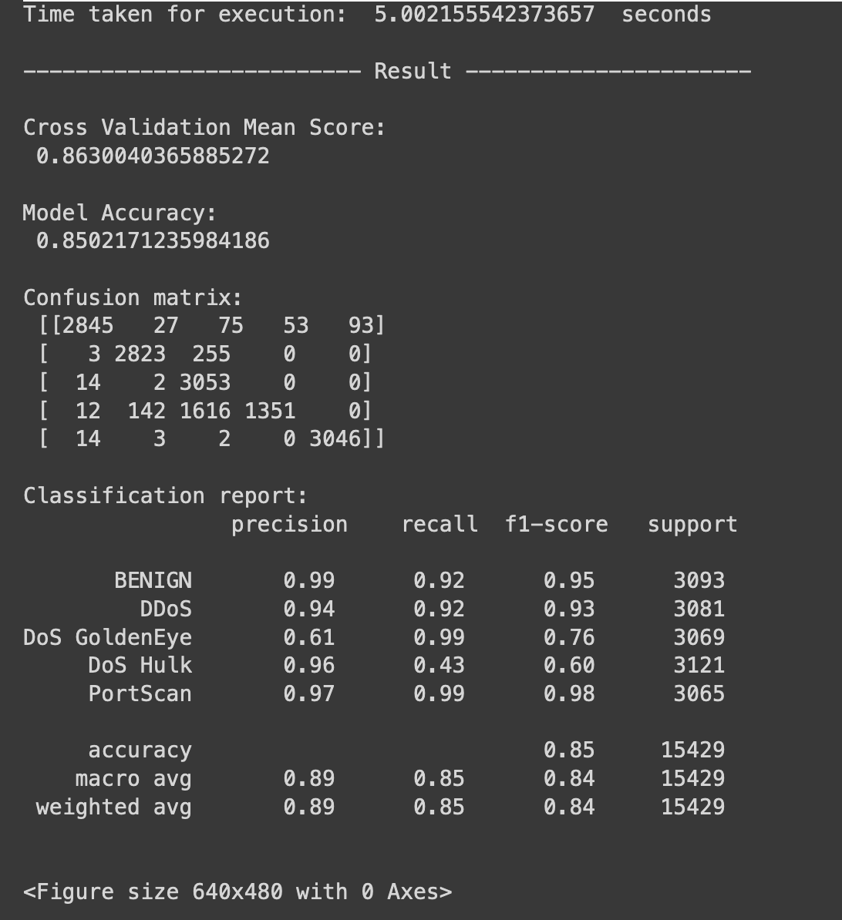

We ran Gaussian Naive Bayes for different numbers of features that were extracted using PCA.

We observed that there is no change in accuracy of the model based on the number of features.

